Bamboo Deployment Steps

- We have created a bamboo build plan, so for that build plan we need to create a deployment project.

- We need to Create deployment project
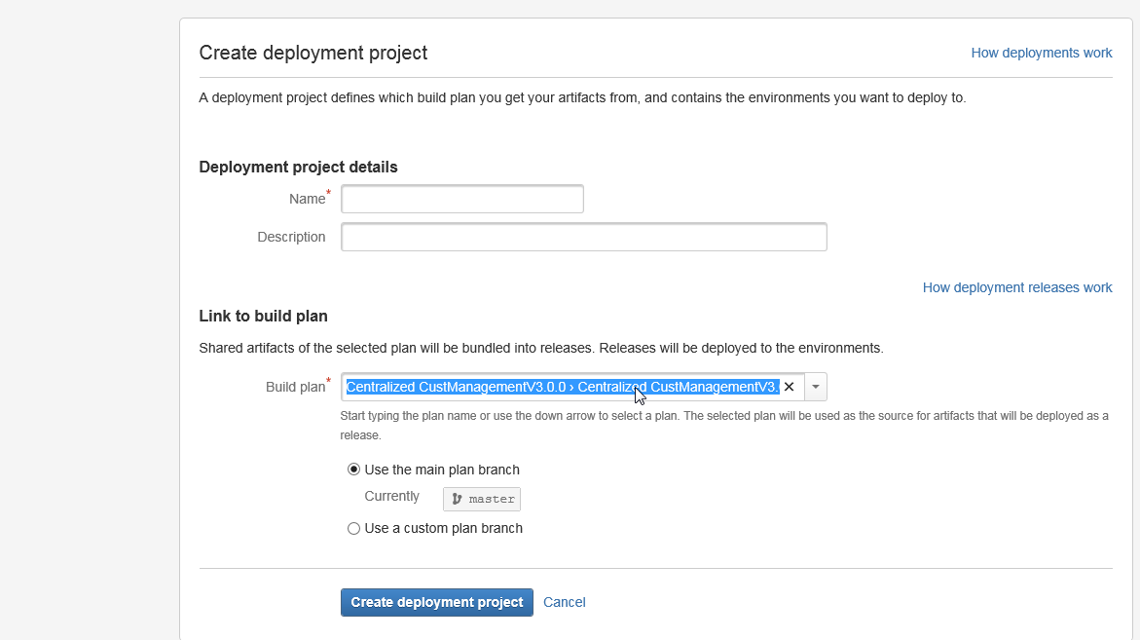
- Here we need to specify the deployment project name and we need to link our build plan as mentioned above screen shot and click create deployment project.
- We have to click “Edit Task” button to configure as per our requirements.
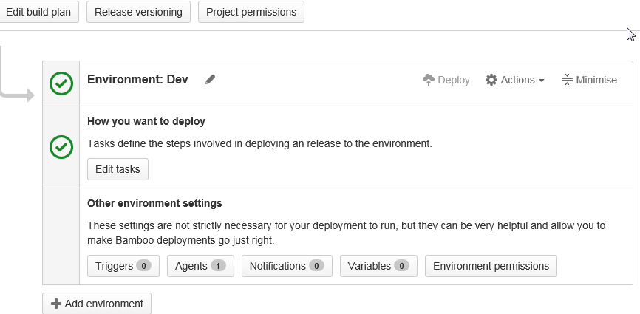
- Click Add Environment and need to mention is this for Dev / TST / INT etc..
- Then we will able to see 2 task default * Clean working directory task and Artifact download. This two will be fetching default with the bamboo build plan configured in deployment.
- After that we need to deployment folder in our corresponding environment, In my case I am looking in to dev environment. SSH task it to create or deploy our files. SCP task is used to copy the files from one server to another.
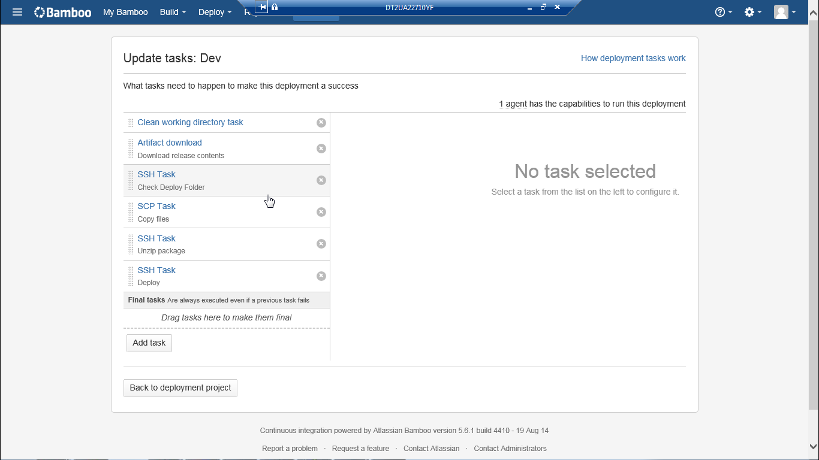
- One important thing our deployment is based on our build process.
- Once build server is done, we need to go for deployment process, so it will get the build zip and .ear file from the build server and copy it files in the deployment server.
- In Agents options we need to mention our deployment server details as below.
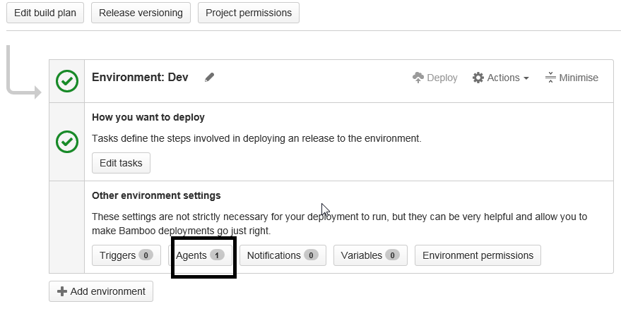
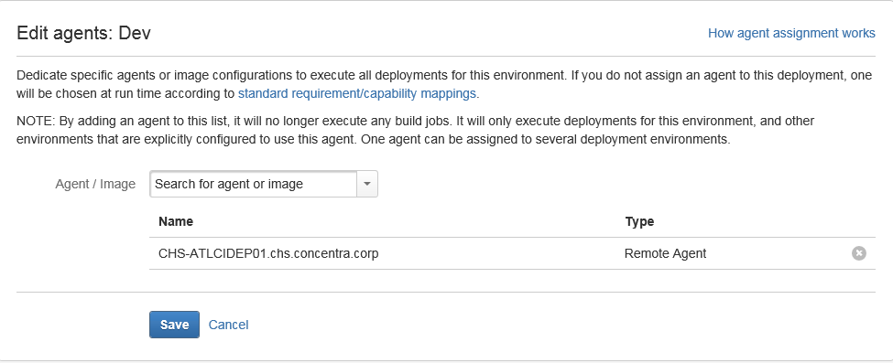
- So we are fetching the corresponding file from build server to deployment server.
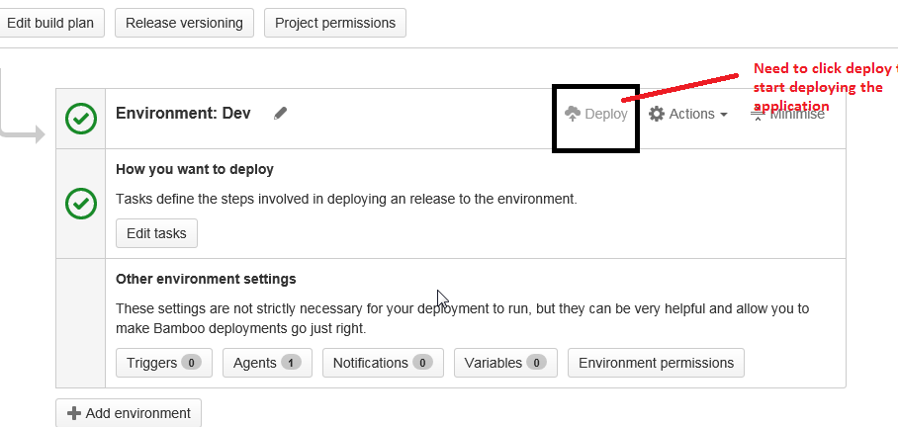

- Once deployment successful you will get the below screen.
